Logo ideas



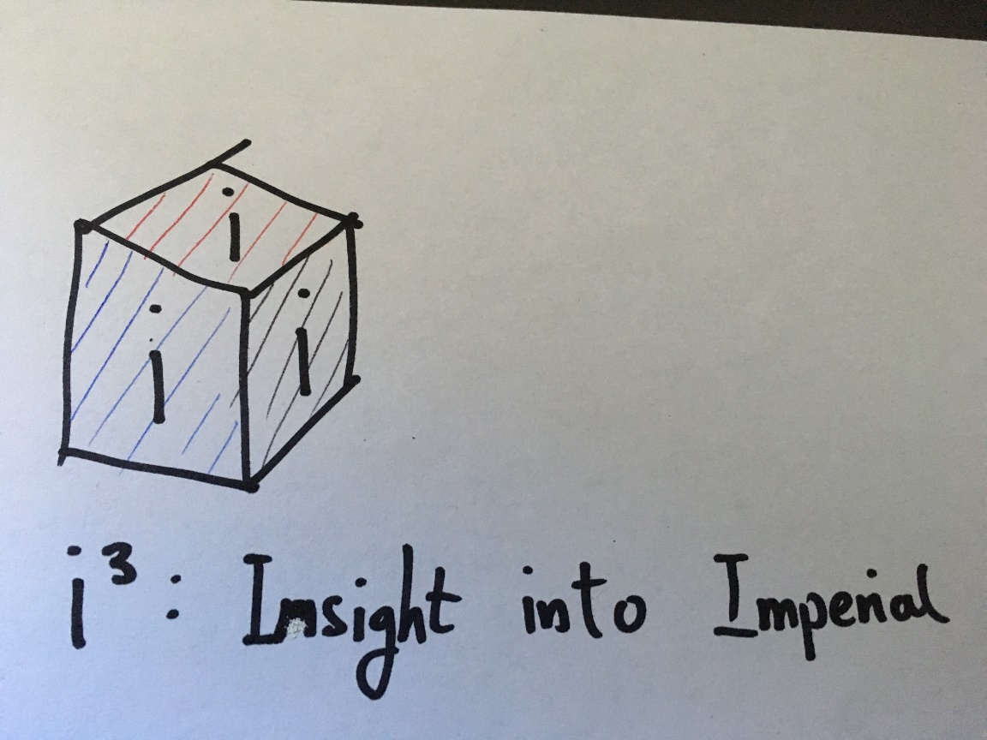



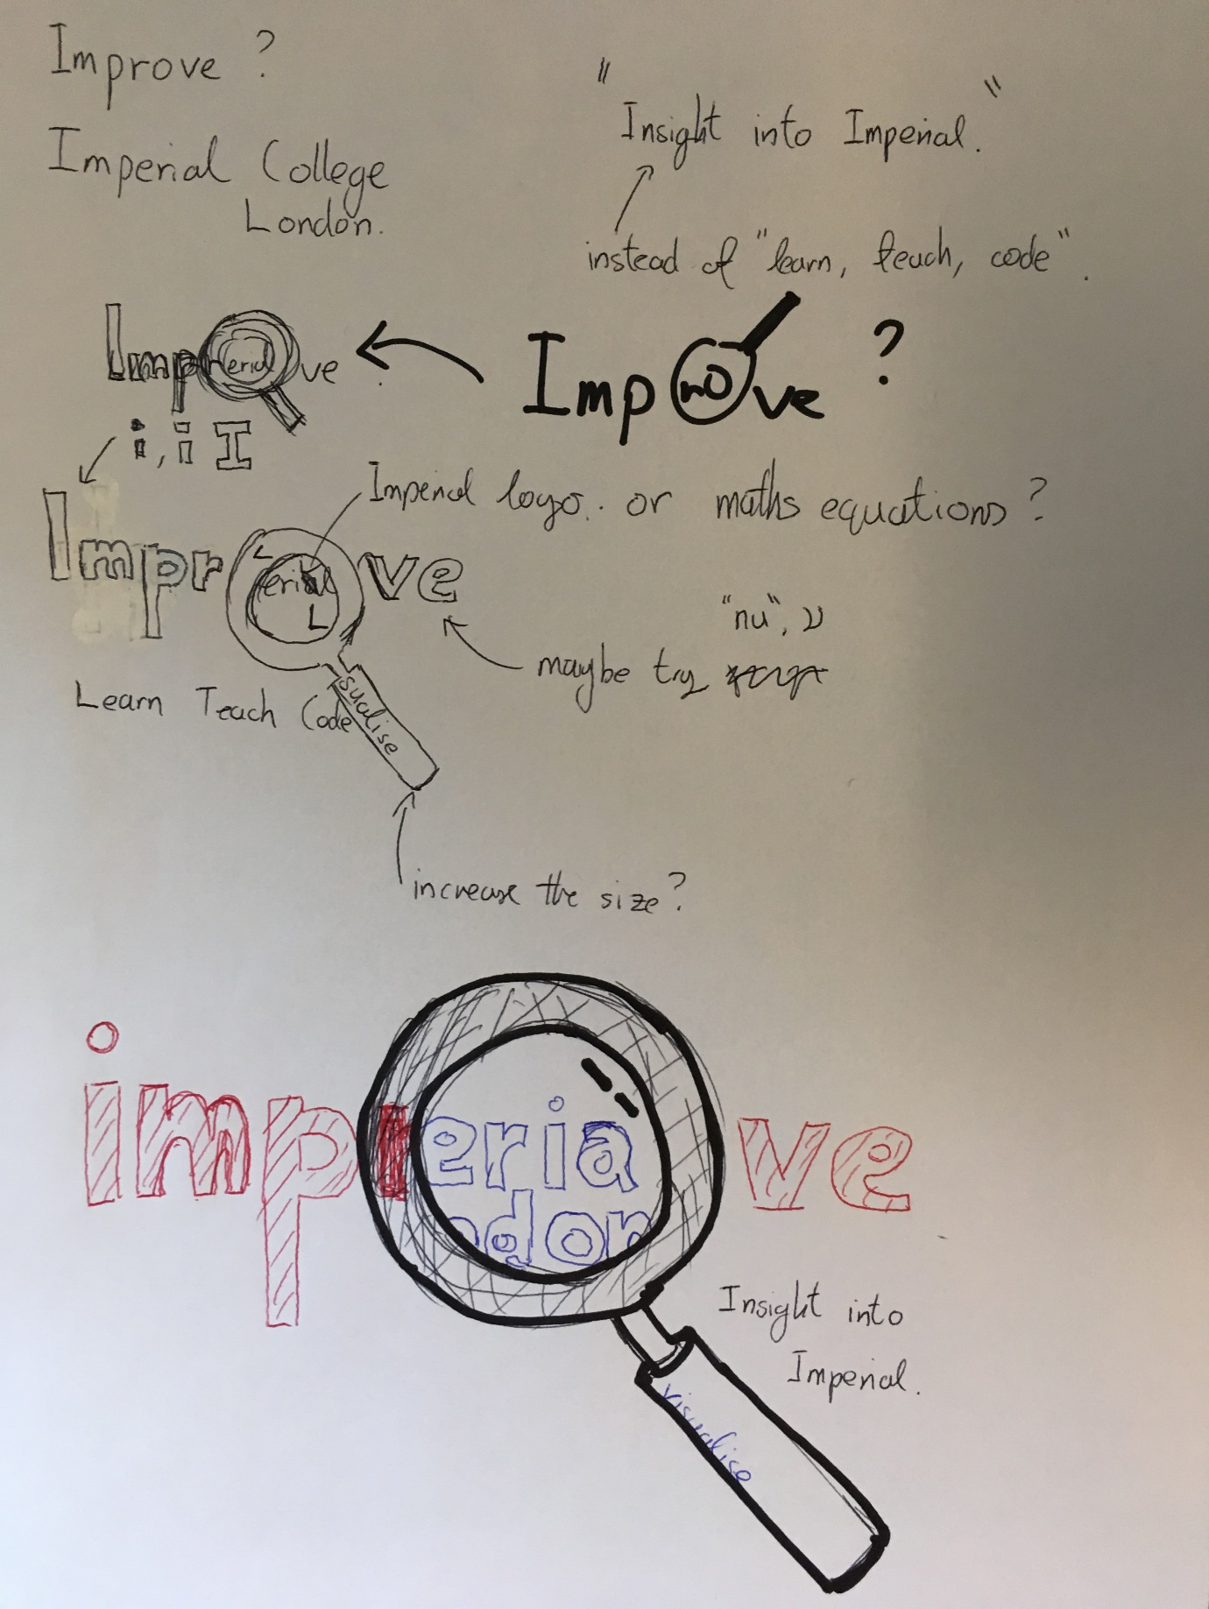

Name ideas

* Imperial Visualisations
* IMProve
* Phyzual
* ICSee
* ImpSight
* Phission
* IMPVisibles / IMPvisibility
* IMPerceptibles / IMPerception